**SAP BW/BO Exercise**

**Exercise#: HANA Data Modeling**

**Student Name: Nupur Ray Student Id: nxr163130**

**Date: 10/06/2016 HANA Login Id: GBI_345**

**Note: You must use the following conventions to name objects/systems created in this exercise.**

**Replace S with the semester**

**A for Fall**

**B for Spring**

**C for Summer**

**Replace XX with the two-character year (ex. 20 for 2020)**

**Replace YYY with your Student ID (ex. 147 if you were issued ID GBI_147)**

**Please use the screenshots ONLY as a reference. The instructions have to be followed AS-IS.**

**Objective**

In the previous exercise we created sales analytic view. In this exercise we will be creating another analytic view for the planned data and combining these two analytic views in a calculation view.

**1.) Create the database table**

We will create a table which is similar to the **sales_yyy** table created in the first data modelling exercise but which has data forecasted for the years 2021 to 2026.

**Remark:** You create all database tables in the database schema GBI_YYY where YYY defines the student number provided.

* 1. ) Open SAP HANA Studio
  2. ) Go to ‘SAP HANA Modeler’ prospective

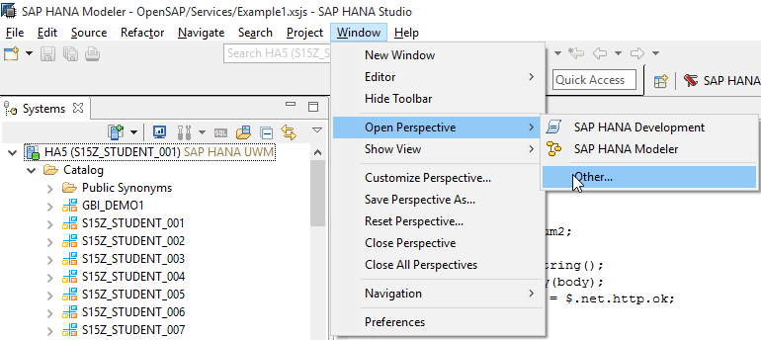

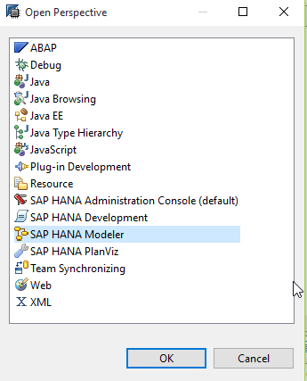

**REMARK:** Make sure you use your designated schema in the instructions

* 1. Open schema corresponding to your user name (GBI_YYY) and go to “Tables” folder:

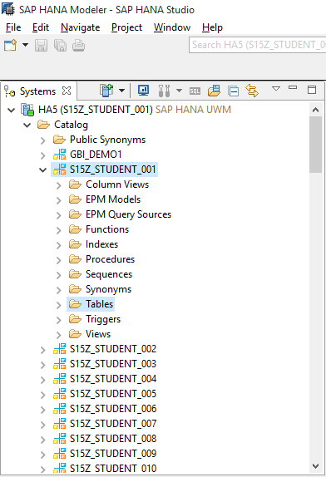

* 1. Right click on Table folder and enter Table Name, Field Name, SQL Data Type and Dim (Field Length) as given below:

Use following details to create the table:

**Table name:** SALESS_PLAN_YYY

**Table type:** Column Store

Add following columns to the table:

|  |  |  |  |
| --- | --- | --- | --- |
| Name | Key | Data type | Length (Dim) |
| ORDER_ID | X | VARCHAR | 10 |
| ORDER_DATE |  | DATE |  |
| ORDER_PRIORITY |  | VARCHAR | 15 |
| ORDER_QUANTITY_PLAN |  | INTEGER |  |
| SHIP_MODE |  | VARCHAR | 30 |
| SHIPPING_COST |  | DECIMAL | 17,2 |
| PRODUCT_ID |  | VARCHAR | 18 |
| CUSTOMER_ID |  | VARCHAR | 20 |

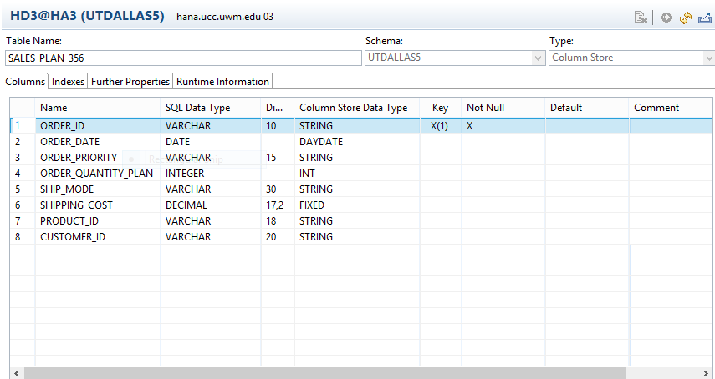

**Note:** Make sure you include all the fields mentioned in the table as the same data tables will be used further for reporting

**a.) Question:**

**Paste the screenshot of SALES_PLAN_YYY table definition created (Right click on the table and click on ‘Open Definition’)**

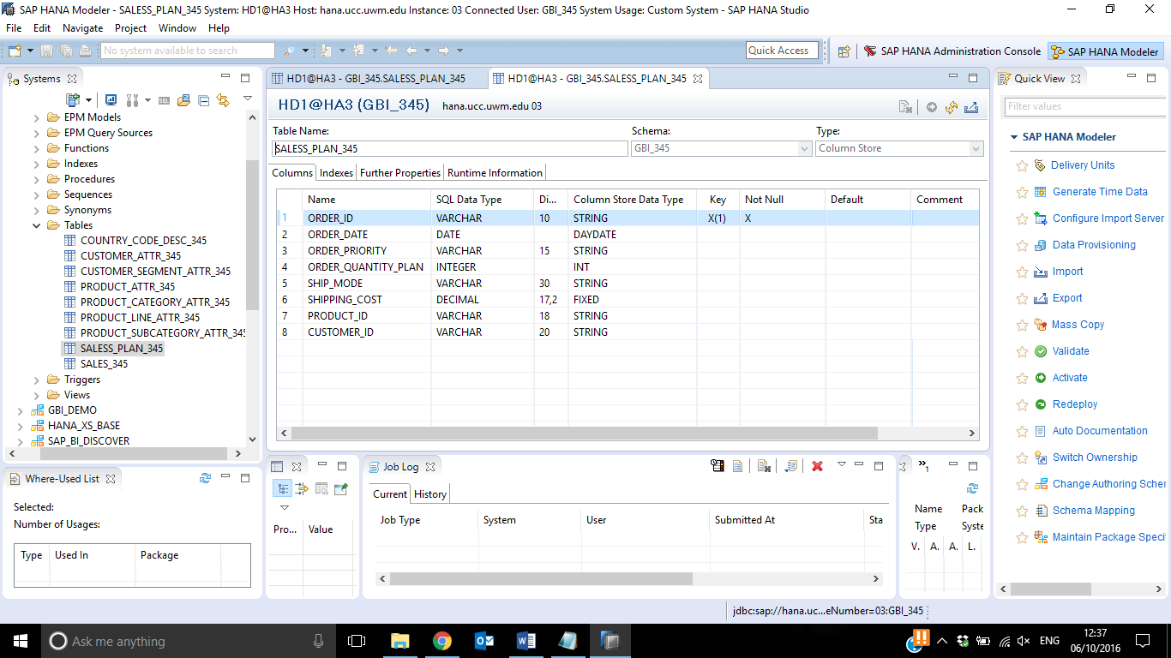

**Data Provisioning**

2.1)Select the HANA System in the Navigator and click on File → Import

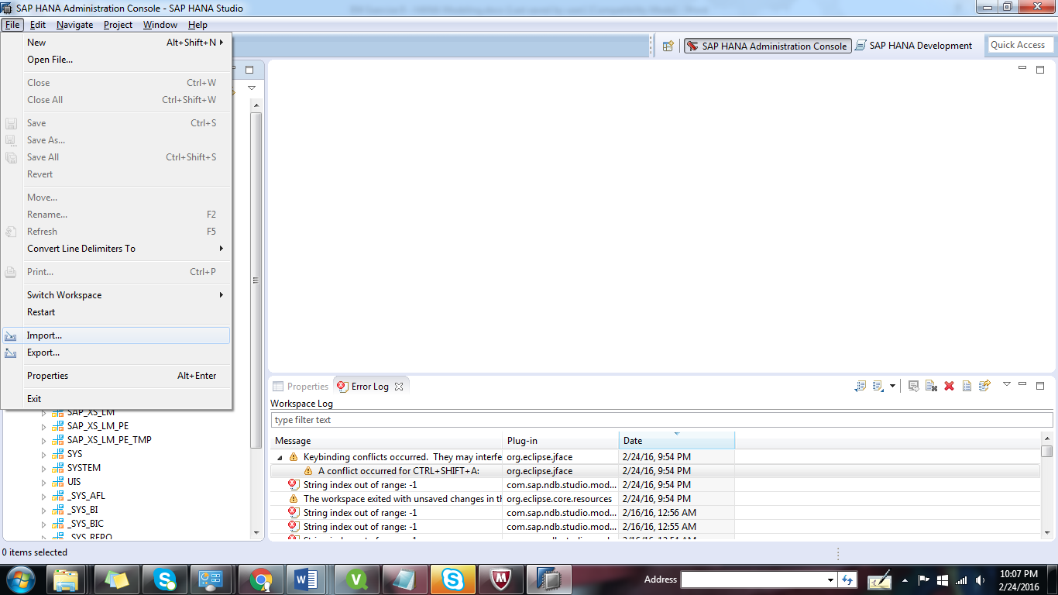



* 1. 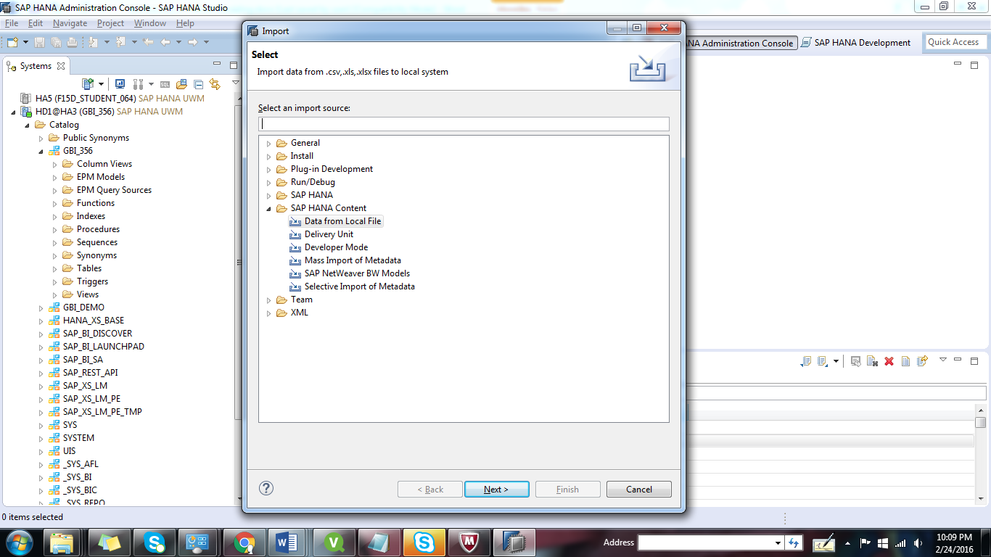Select SAP HANA Content → Data from Local File and click on Next.
  2. Select the system in which you want to import the flat file and click on Next.

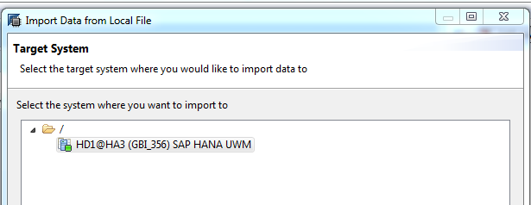

* 1. Select Flat File
  2. Download dataset file provided in eLearning along with the exercise.
  3. Click on Browse to the select the files that you have saved in previous step.
  4. After you selected the file, change the different properties of the file import to match the properties of the CSV-File (as shown in the screenshot).
  5. If you create a new table, make sure that you selected your schema (GBI_S##) and you assigned a proper table name. In this scenario, since you have already created a target table, you can do it by selecting the Existing radio button and clicking on Select Table.

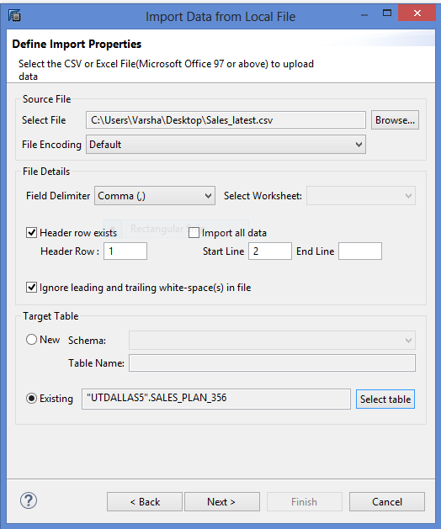

* 1. Manage Table Definition and Data Mappings

Drag & drop each source field from .csv file to the corresponding target field of Target table as seen in the screenshot.

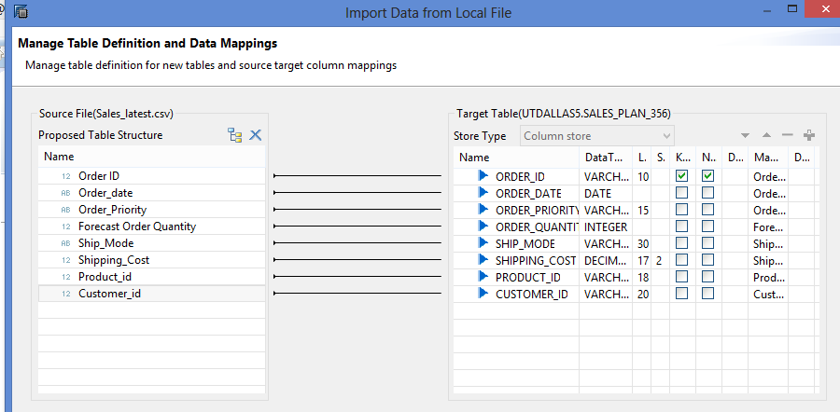

2.10) After you have pressed FINISH*,* you will be directed to the job log.

If the batch job has been performed successfully, you should see a corresponding message in the bottom line of the job log as seen in the screenshot.

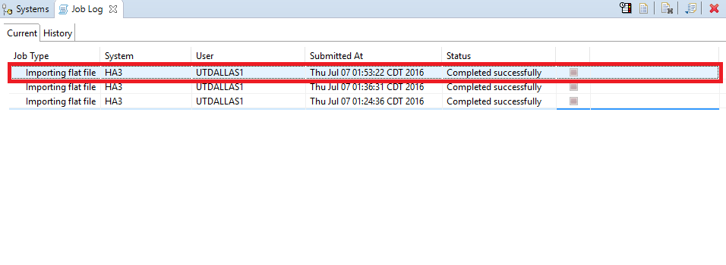

**3.) Viewing the Data**

* 1. Open the SAP HANA Studio

Navigator View → Catalog → GBI_YYY → Tables → **SALES_PLAN_YYY** → Right click→ Open Data Preview.

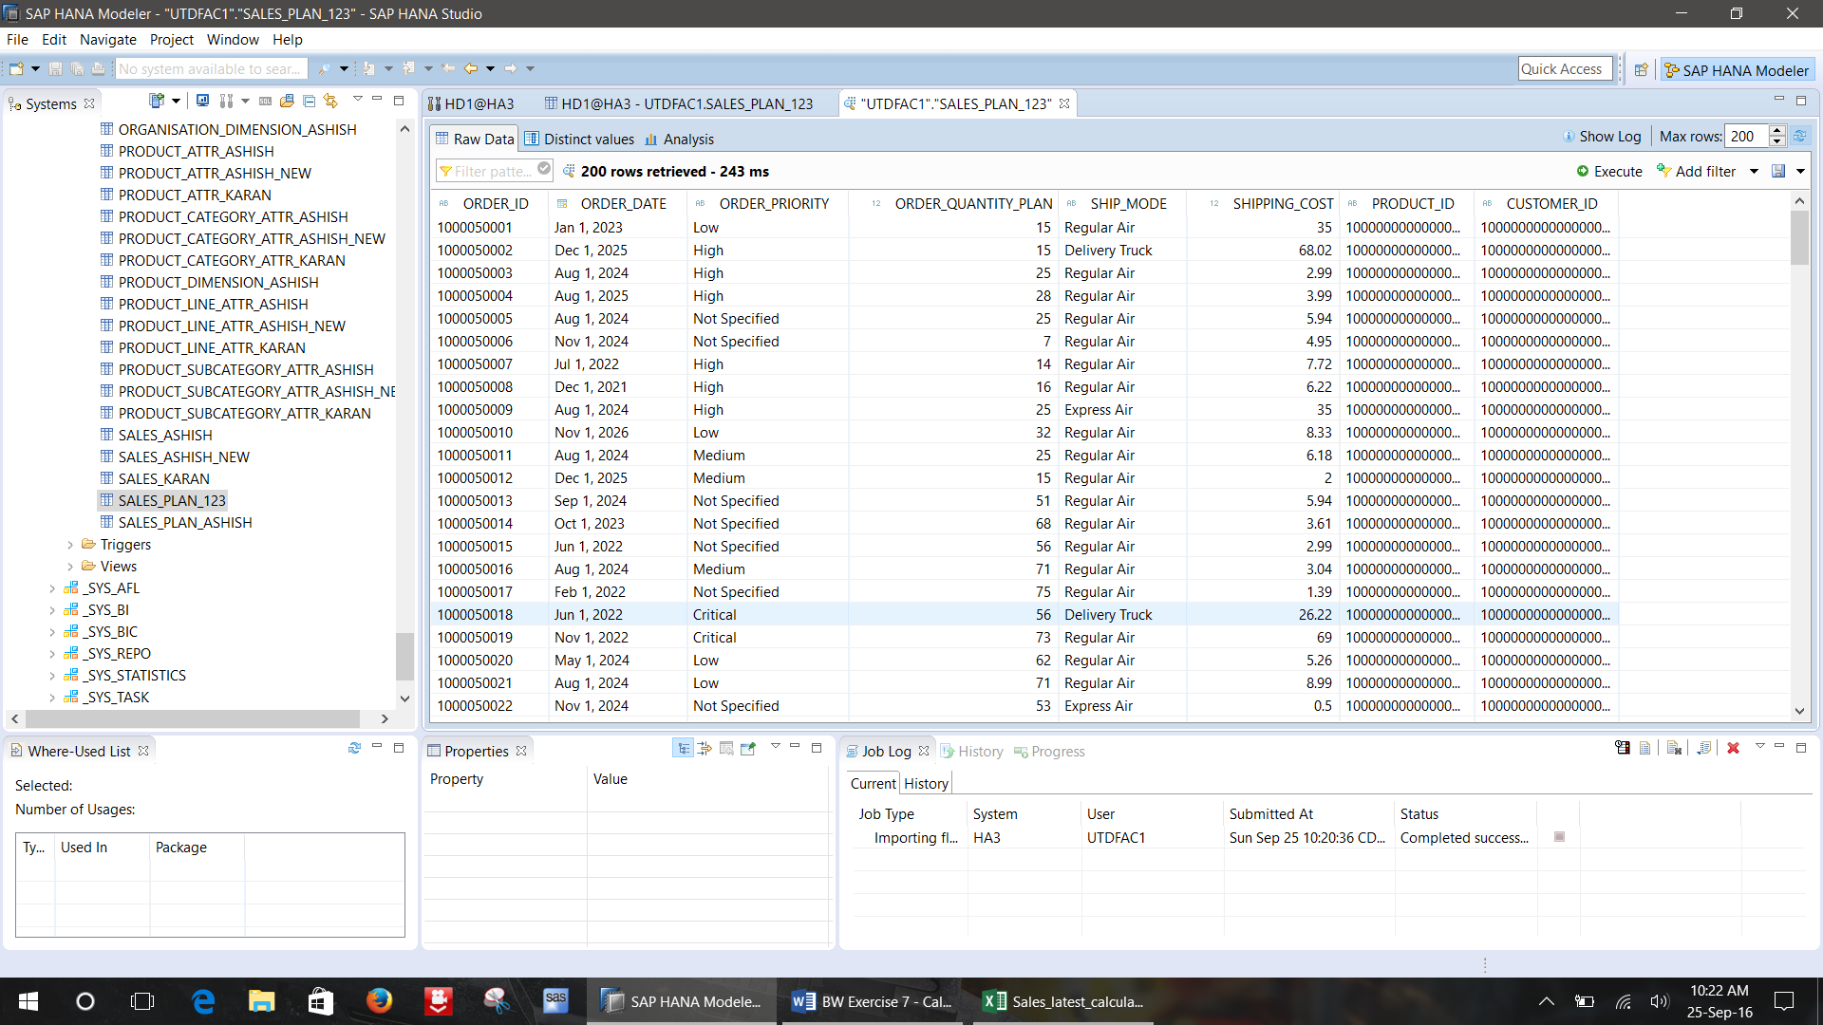

**Note:** If the data doesn’t look like what you expected please go back and check the file type.

**Question:**

**b.) Paste your screenshot of data preview for the table**

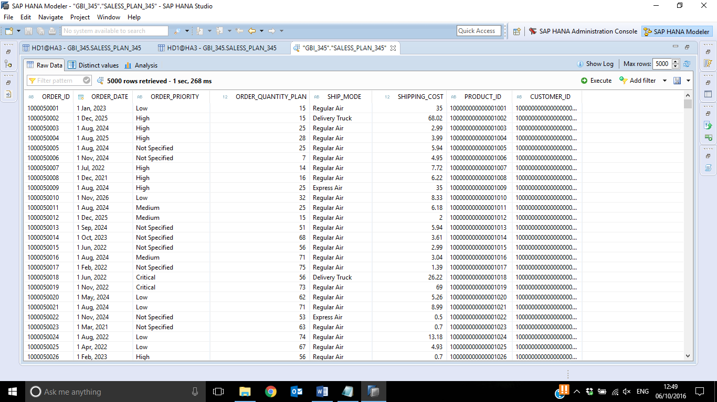



**4.) Create an analytic view**

Create a new analytic view for the planned data in your package

Use following details to create the view:

**Package name**: SXX.GBI_YYY

**View name**: PLAN_AV_**YYY**

**Label**: PLAN_AV_**YYY**

**Tables:** SALES_PLAN_**YYY**

**Views:** CUSTOMER_ATV_**YYY and** PRODUCT_ATV_**YYY**

**Steps**:

* 1. Generating time data: To generate the data from the years 2021 to 2026 we need to do the following steps:

1. Goto Help 🡪 Quick view 🡪 Generate time data

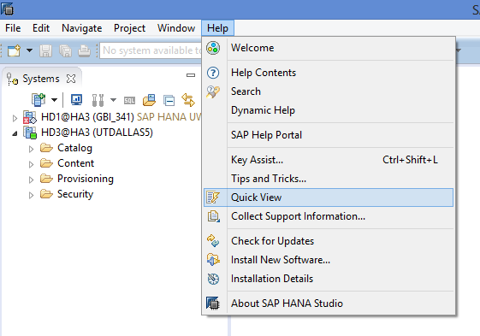

1. Select the options as per the screen shot:

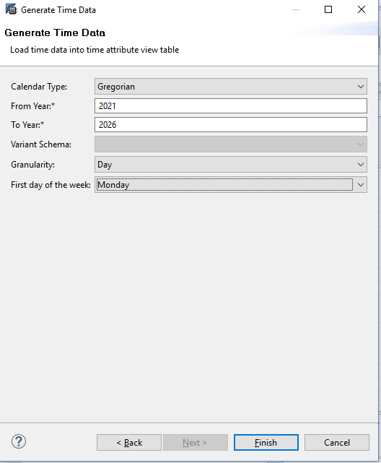

* 1. Open Navigator View
  2. Goto Content and Package **SXX.GBI_YYY** → Right click → New → Analytic View

**Note:** The name and description of the view should be according to the convention mentioned above

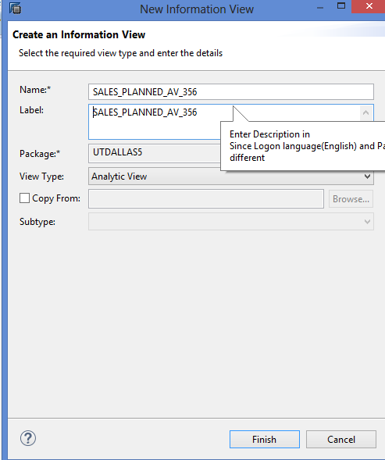

* 1. Add the **Sales_plan_YYY** table to Data Foundation. Right click 🡪Add Objects

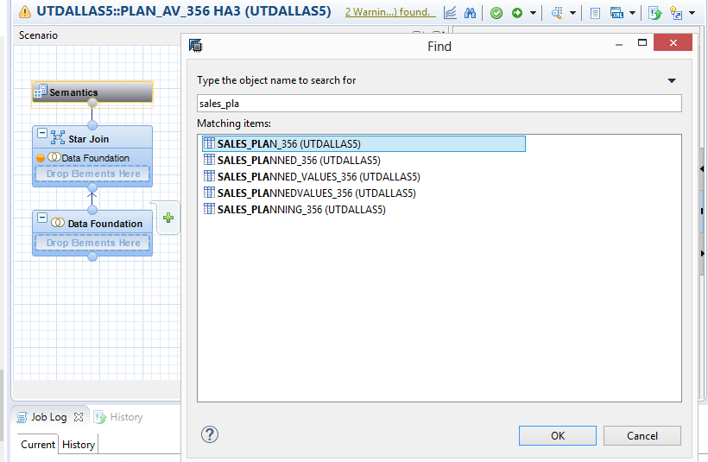

* 1. Add the **M_TIME_DIMENSION** table to Data Foundation. Right click 🡪Add Objects

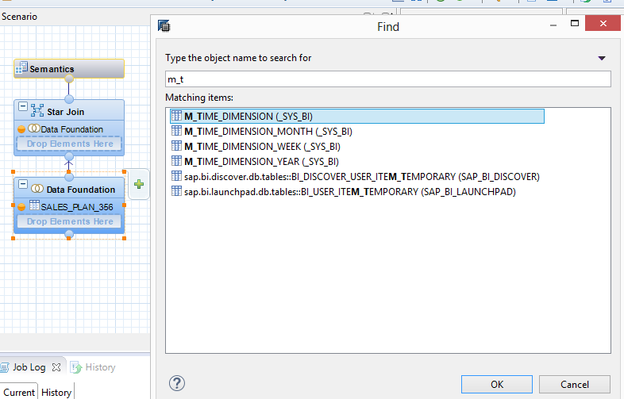

* 1. On the Data Foundation component, select the relevant fields of table **SALES_PLAN_YYY** and choose Add to Output to add them to the output structure.

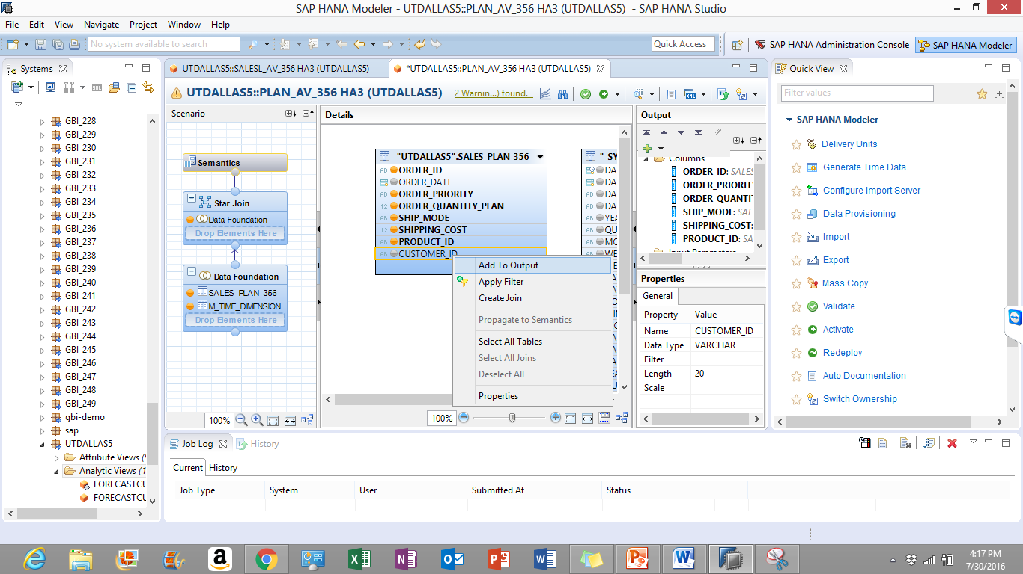

* 1. Click on Data Foundation. Join **SALES_PLAN_YYY** and **M_TIME_DIMENSION** using referential join. Drag and drop **ORDER_DATE** TO **DATE_SQL**

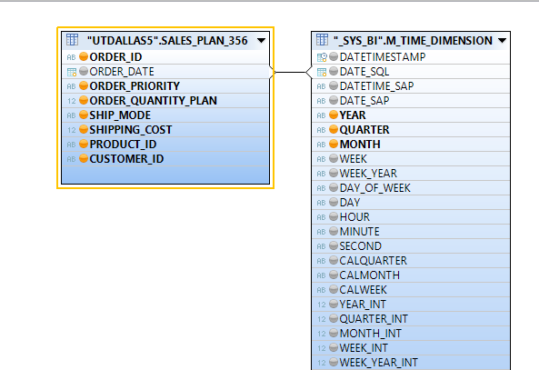

* 1. The following should be the output structure of the Data Foundation:

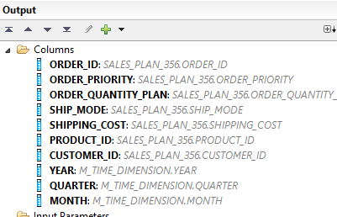

* 1. Add the previously created attribute views to Logical Foundation

Right click 🡪Add Objects

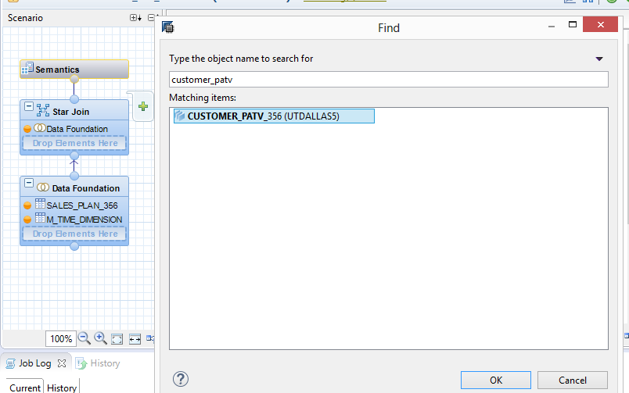

Press Ok.

Similarly, add Product view

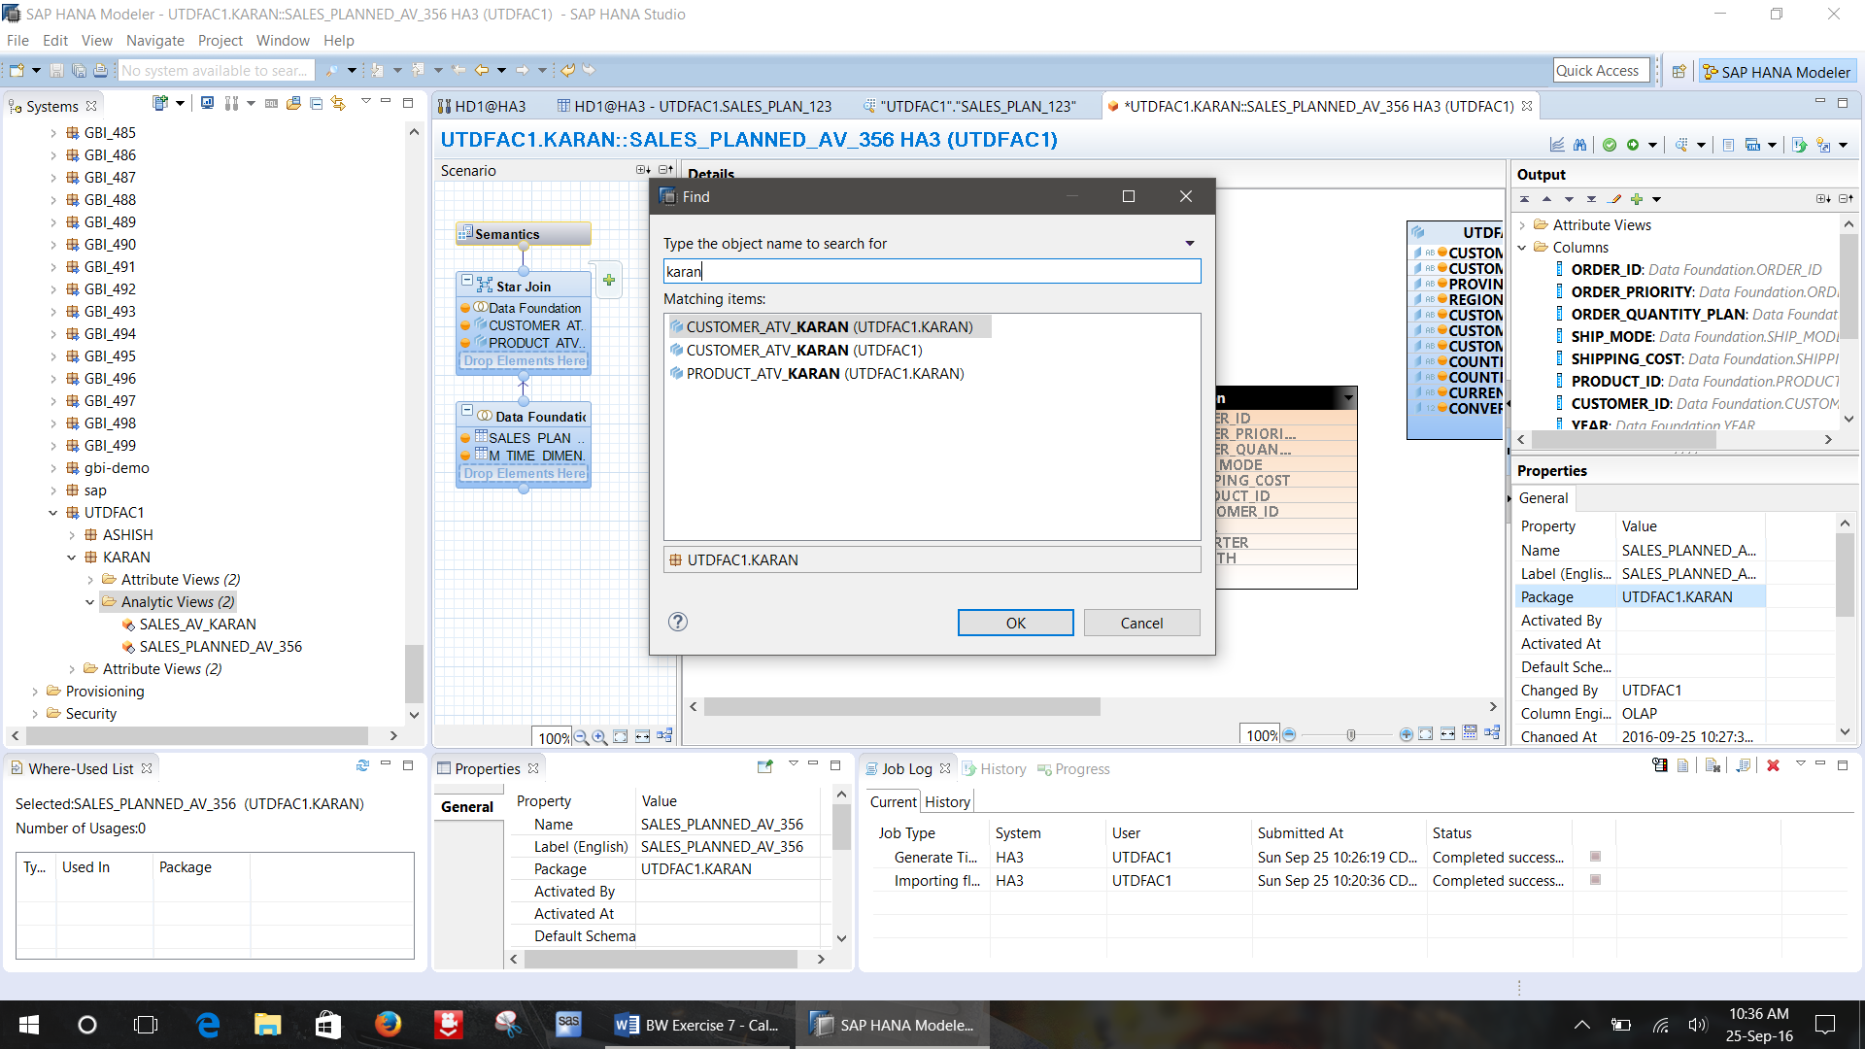

* 1. Join the **Sales_plan_yyy** table with the product and customer view, using a referential join

Switch to the **Logical Join component***.*

Drag & drop field DATAFOUNDATION.CUSTOMER_ID to field CUSTOMER_ATV_YYY.CUSTOMER_ID.

Drag & drop field DATAFOUNDATION.PRODUCT_ID to field   
PRODUCT_ATV_YYY.PRODUCT_ID.

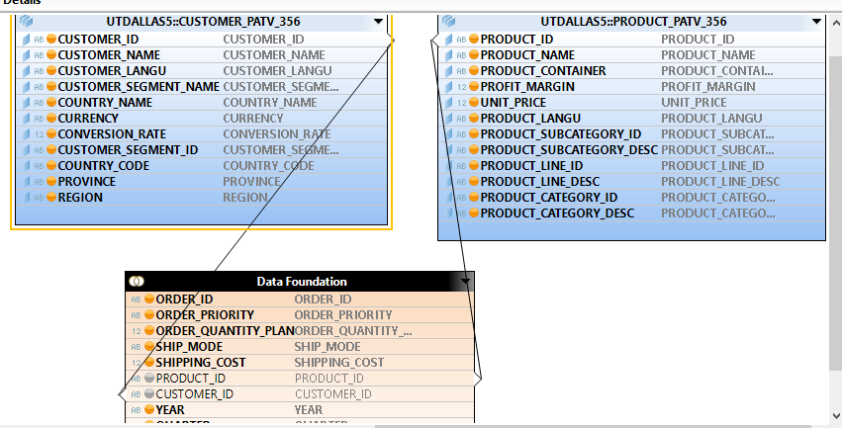

The properties tab should look similar to the screen shot below for both the joins:

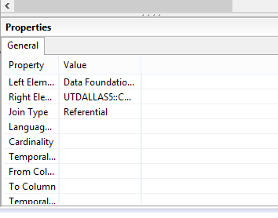

c.) Question: Paste the screenshot of your mappings (joinings) here

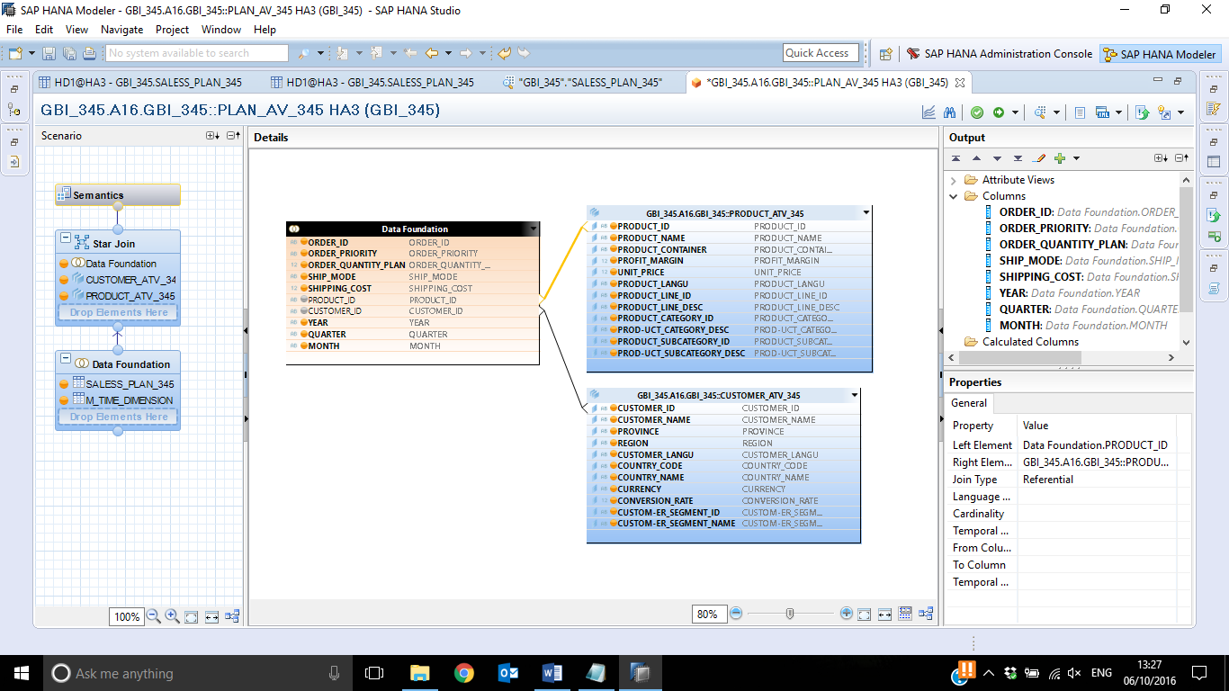

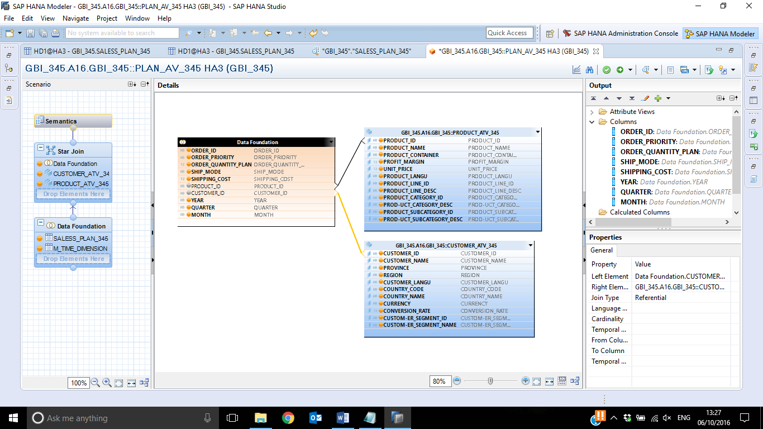

* 1. Select the **Semantics** component to change the type of the output fields as per the screen shot below:

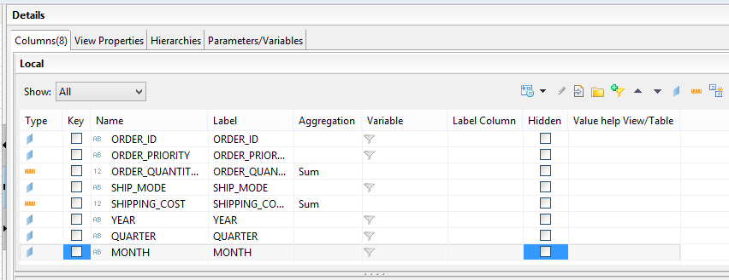

* 1. In the output structure of the analytic view, select the folder **Calculated Columns** and choose New. Enter the details as indicated in the screenshots.

Use following details to create the calculated column:

**Name:** PLANNED_REVENUE

**Description:** PLANNED_REVENUE

**Formula:** (UNIT_PRICE*ORDER_QUANTITY_PLAN)+ SHIPPING_COST

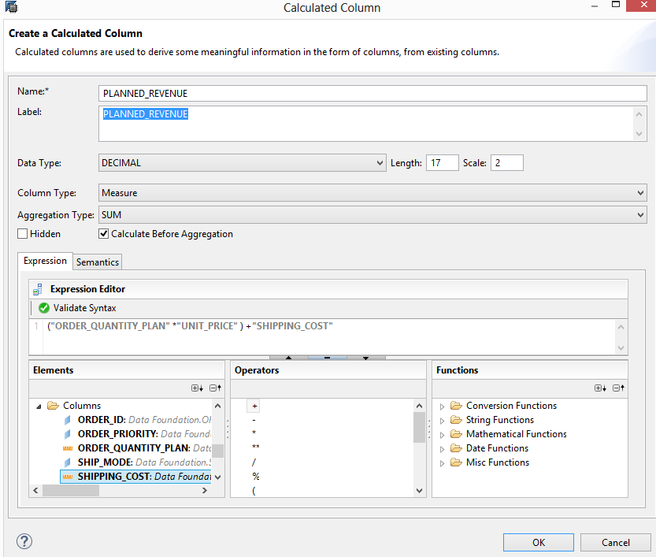

In the **semantics tab**, enter following details:

**Semantic Type**: Amount with Currency code

**Currency:** USD.

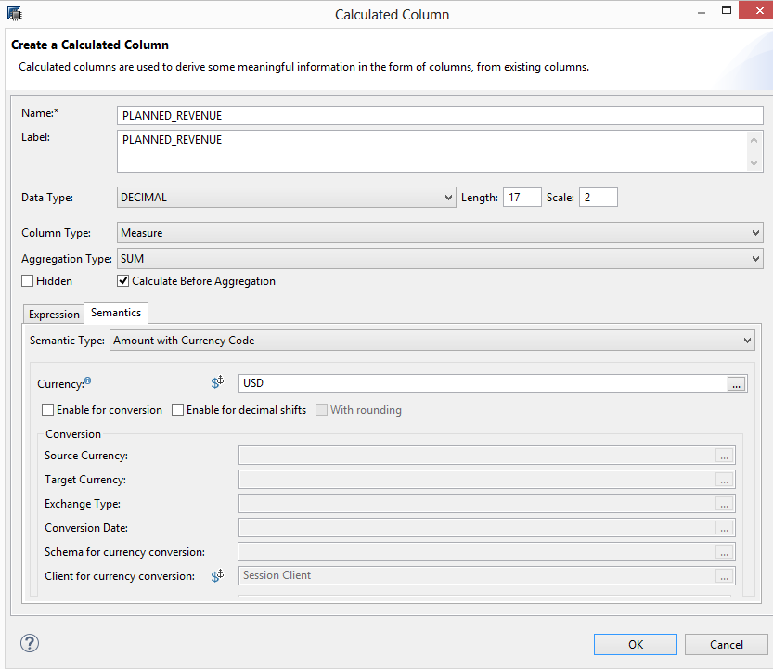

Click OK.

Click on Save and Activate button.

**d.) Question:**

**Open the data preview for the analytic view created and attach the screen shot of raw data**

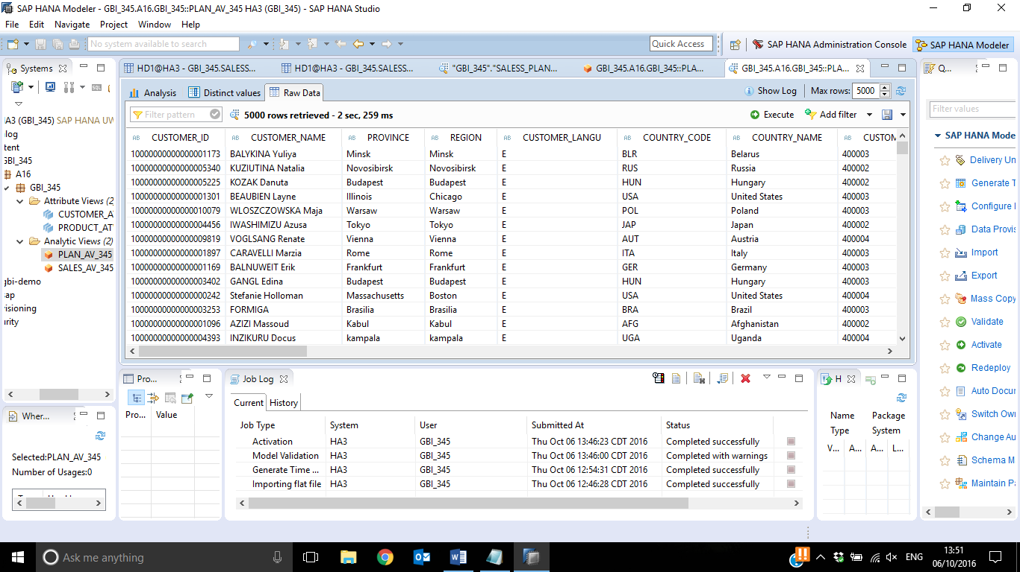

**5.)** **Creating calculation view**

**Objective:**

The purpose of creating the calculation view is to compare the previously created actual sales analytic view and the planned analytic view created in this exercise.

**Steps:**

Use following details to create the view:

**Package name**: SXX.GBI_YYY

**View name**: ACTUALREVENUE_VS_PLANREVENUE_CV_**YYY**

**View description**: ACTUALREVENUE_VS_PLANREVENUE_CV_**YYY**

**Views:** SALES_AV_**YYY and** PLAN_AV_**YYY**

5.1) Go to the Navigator View, expand the content folder, On the Package **SXX.GBI_YYY** → Right click → New → Calculation View and enter the name, description as per the above mentioned convention

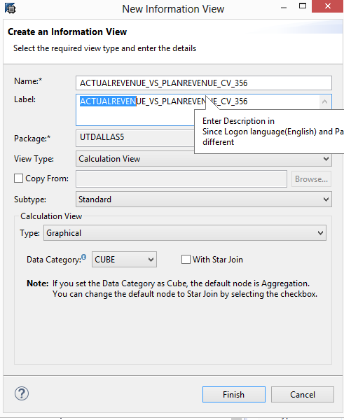

5.2) Add **two projection nodes** to the modelling screen. Add the analytic view **SALES_AV_YYY** to the first projection node(**projection_1**) and the analytic view **PLAN _AV_YYY** to the second projetion node**(projection_2)**

In oder to add the views to the projection nodes, Click on the **“+”** sign beside the node or right click on the node and select **Add objects.**

Use the following two screen shots for reference.

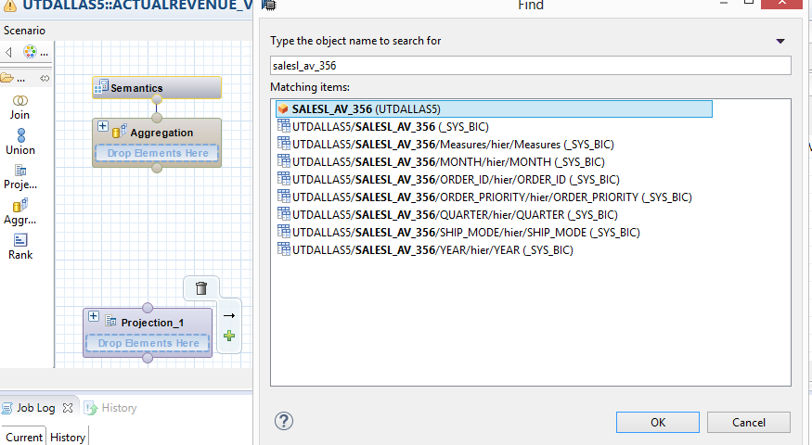

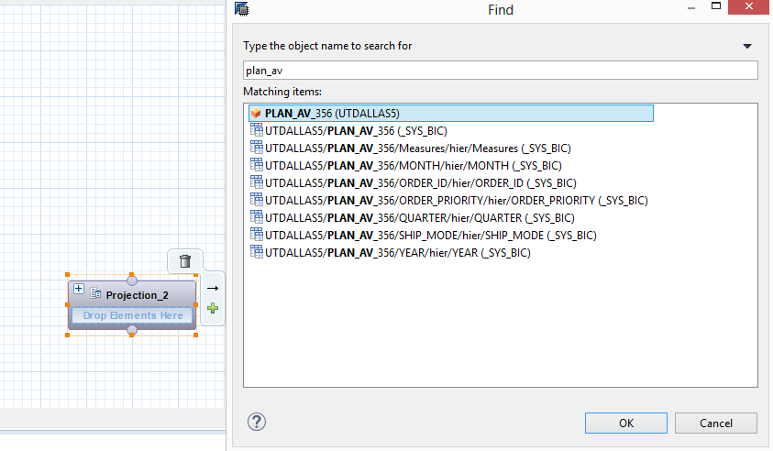

5.3) The **output structure** of the first projection node should be similar to the screen shot below

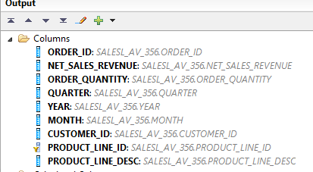

The output structure of the second projection node should be as follows:

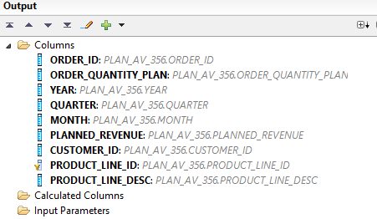

5.4) In the output structure of the projection_1 node and click on **expressions** under **filters** and click on **New**

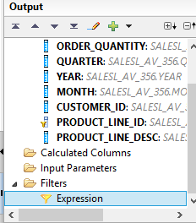

5.5) Enter the expression as shown in the screen shot:

In the **Expression editor** add the formula as shown in the screen shot

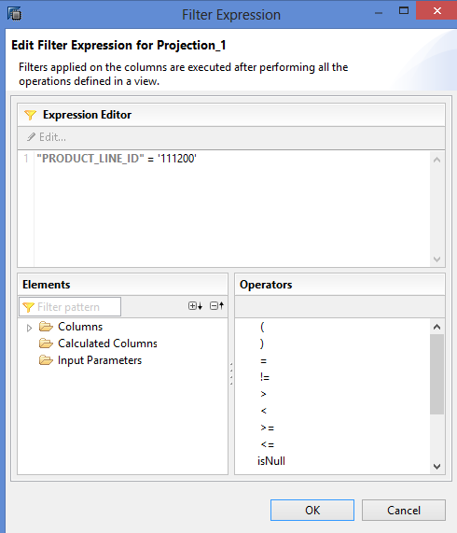

Click ok

5.6) Similar to the above step create a filter for the second projection node (PLAN_AV_YYY) and add the expression **"PRODUCT_LINE_ID"** ='111200'

**e.) Question**

**Paste the screen shot of the expression editor for the second projection node (PLAN_AV_YYY)**

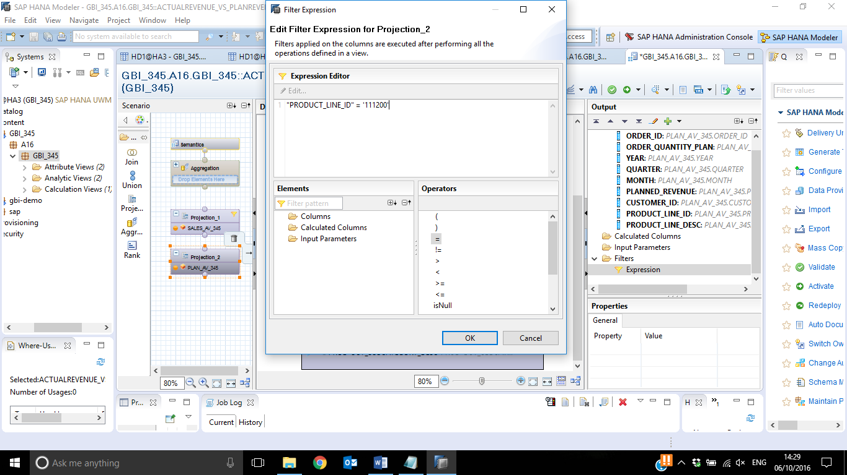

5.7) Add aggregation node to the modelling window and connect **projection_1** node to it. Drag and drop the arrow from **the projection_1** node to the aggregation node inorder to join them

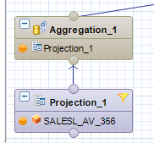

The output structure of the **aggregation_1** node should be as shown in the screenshot:

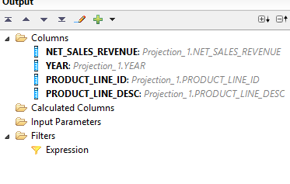

5.8) similarly add aggregation node to projection_2 node and the output structure of it should be as shown in the screenshot:

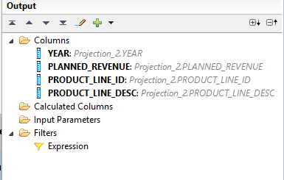

5.9) Drag and drop a **join** node to the modelling window and connect **aggregation_1** and **aggregation_2** to it

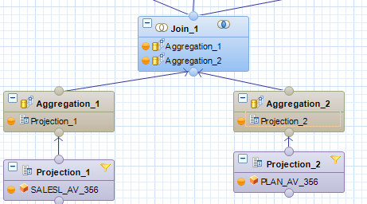

In the details tab join **aggregation_1.year** to **aggregation_2.year** using an inner join

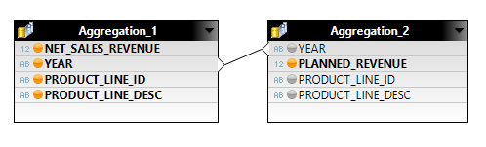

This is how the properties of the join should look like:

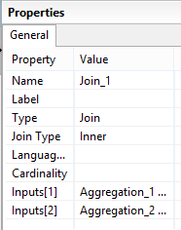

Add the following fields to the output:

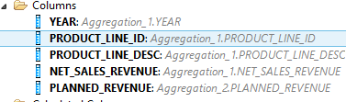

5.10) under the output structure, click on calculated column and select new

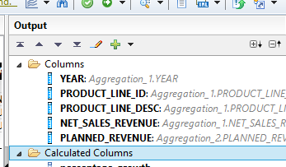

Use following details to create the new calculated measure:

**Name**: precentage_growth

**Description:** percentage_grwoth

**Data type** : Decimal

**Formula:** round(("PLANNED_REVENUE" -"NET_SALES_REVENUE" ) /"NET_SALES_REVENUE",2)

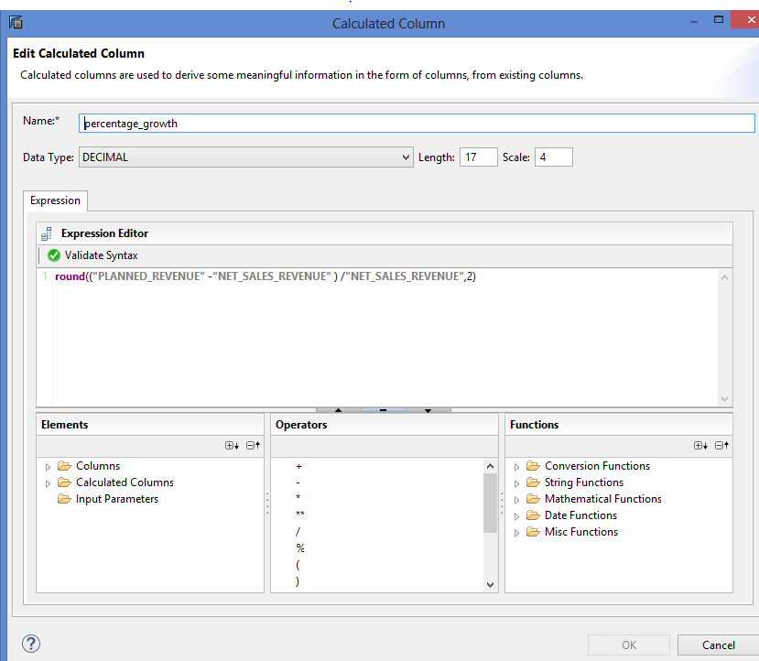

Click ok

Add another calculated column and use the following details:

**Name:** integer_year

**Description:** integer_year

**Data type :** Integer

**Formula:** **int**(**"YEAR"**)

This step is performed to convert the years into integer values

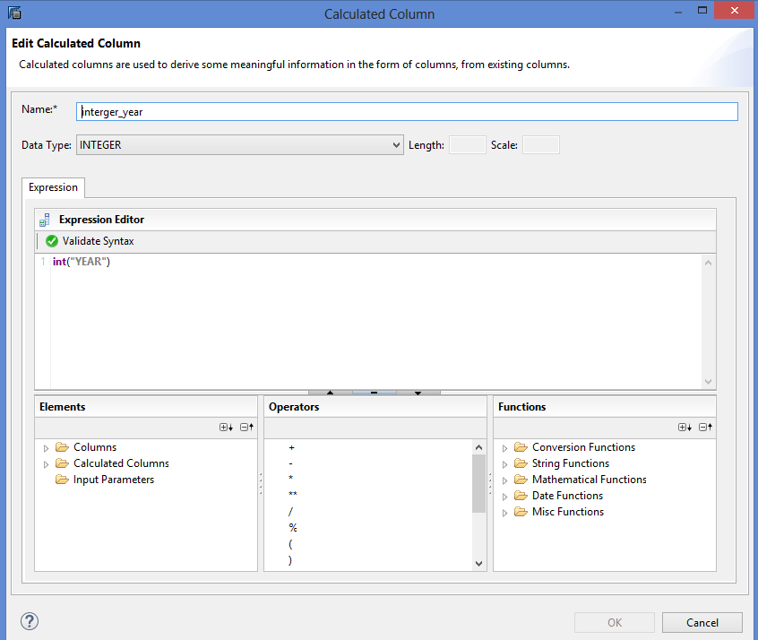

The output structure of **Join_1** node should similar to the screenshot:

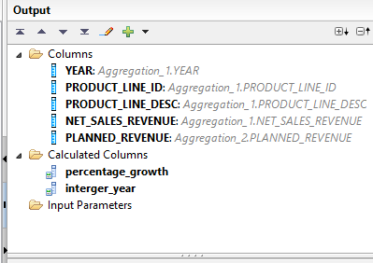

5.11) Drag and drop **aggregation node** and connect **Join_1** node to it. This step is performed to aggregate the percentage_growth

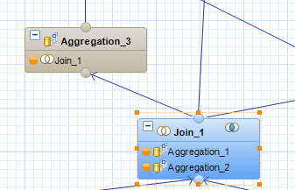.

5.12) Add **product_line_id, Product_line_description and percentage_growth** to the output

5.13) Add a new calculated column and use the following details:

**Name:** newyear

**Description:** newyear

**Data type** : Integer

**Formula:** **2027**

This step is performed to introduce a new year 2027 as we will be calculating the revenue for this year using the 2026’s revenue and average of growth rate

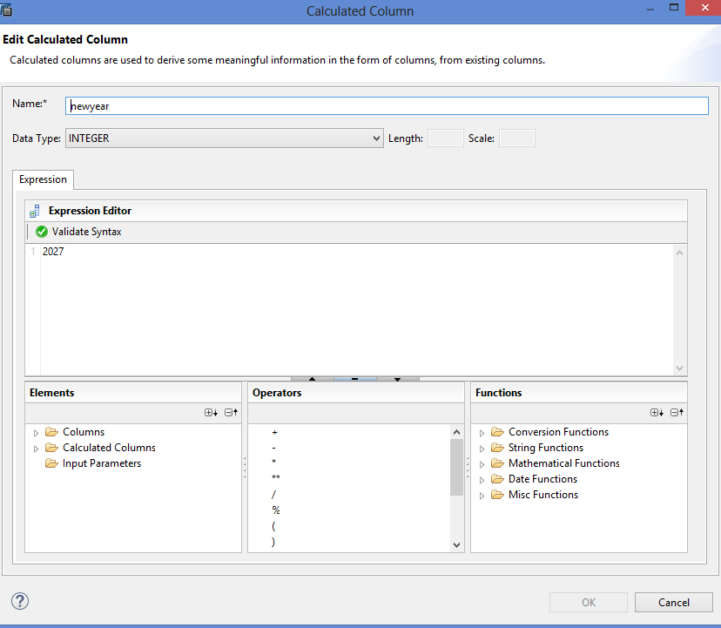

The output structure of the **aggregation_3** node should be as follows:

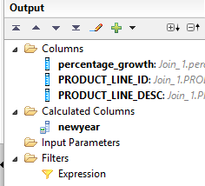

5.14) Drag and drop a **projection node** and connect **aggregation_3** node to it

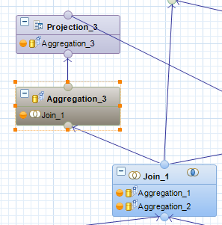

5.15) Add **percentage_growth, Product_line_desc, product_line_id and newyear** to the output

5.16) Create a new calculated column and use the following details:

**Name:** average

**Description:** average

**Data type :** decimal length :17 scale : 4

**Formula:** **round**(**"percentage_growth"**/6,2)

This step is performed to find out the average of the growth rate

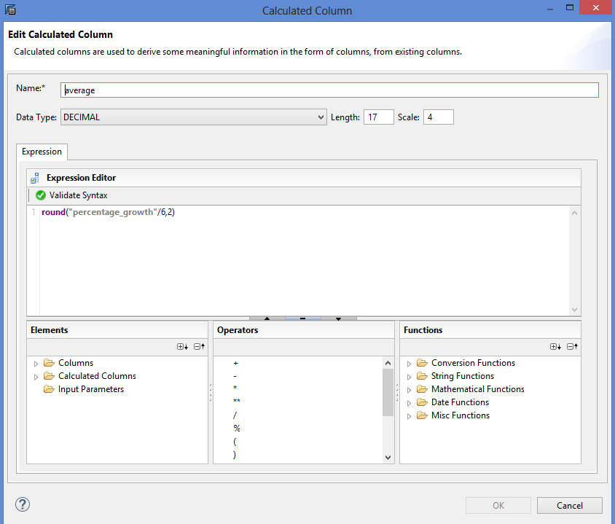

5.17) Create another calculated column, use the following details:

**Name:** joinyear

**Description:** joinyear

**Data type :** Integer

**Formula:** **2026**

This step is performed to add a joining condition using the year 2026, because we use 2026 year’s revenue for the calculation of 2027’s revenue

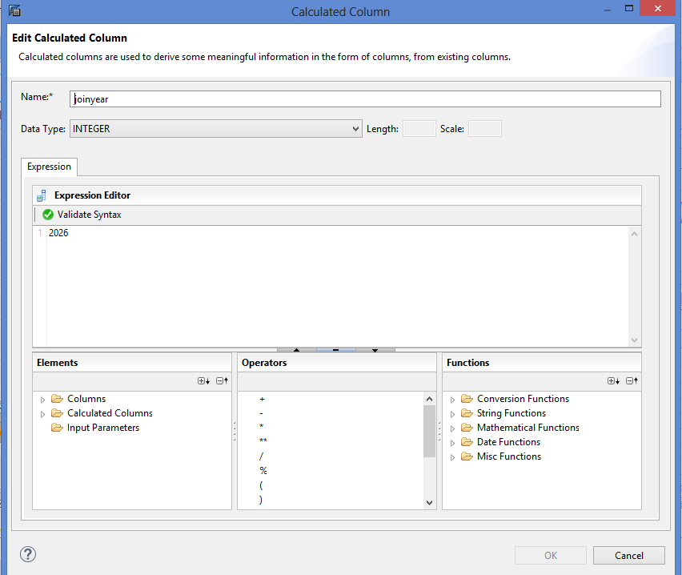

The output structure of **projection_3** node should like the one shown in the screenshot

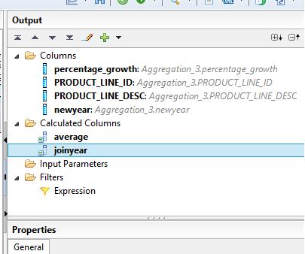

5.18) Drag another **join** node and connect **projection_3** and **join_1** node to it

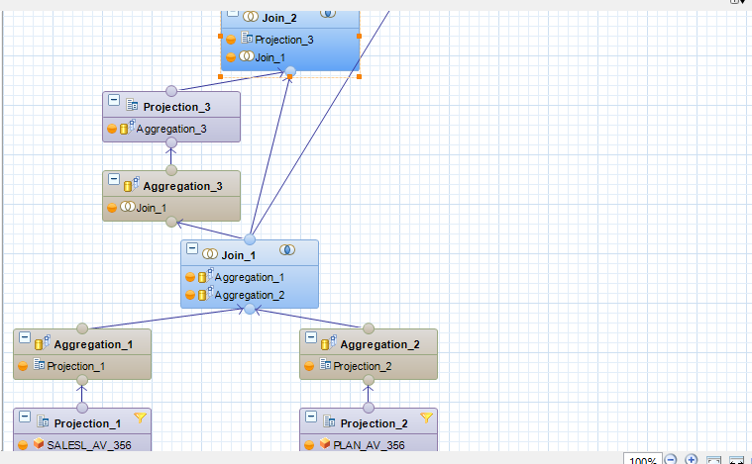

5.19) Join **projection_3.joinyear** to **join_1.integer_year** using an **inner join**

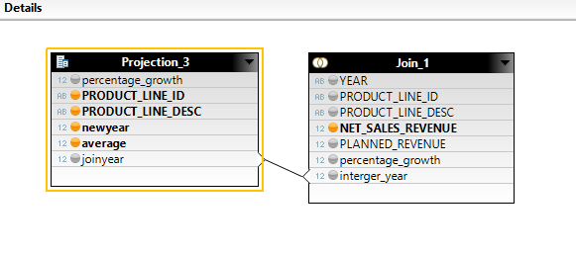

The properties tab should look similar to the screen shot:

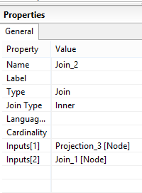

The output structure of **join_2** node should be as follows:

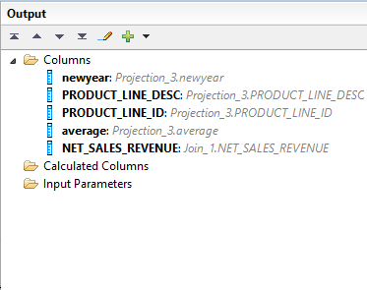

5.20) drag another **projection** node and connect node **join_2** to it

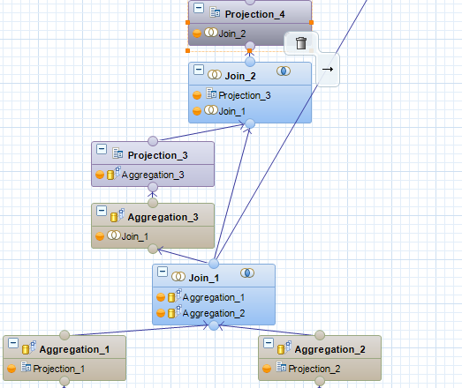

5.21) Add **newyear, product_line_id, product_line_desc, average and net_sales_revenue** to the output

5.22) Create another calculated column, use the following details:

**Name:** revenue_2027

**Data type :** decimal length : 17 Scale :4

**Formula:** (**"average"**) *(**"NET_SALES_REVENUE"**)

This step is performed to calculate the revenue for the year 2027

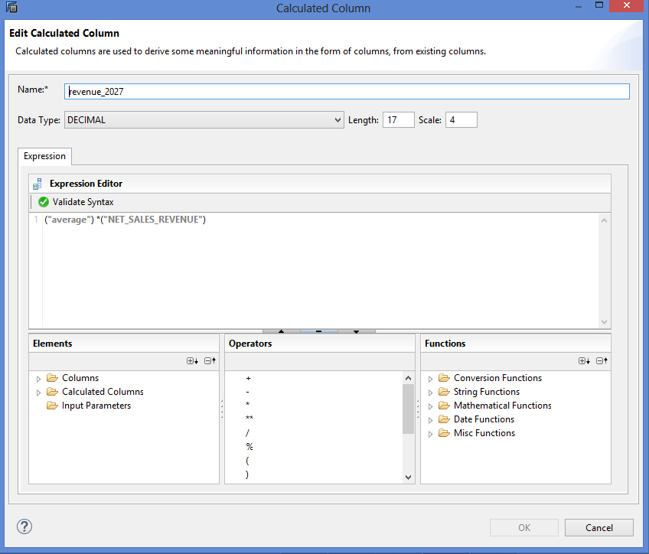

5.23) Create another calculated column, use the following details:

**Name**: newyear

**Data type** : varchar length :4

**Formula:** 2027

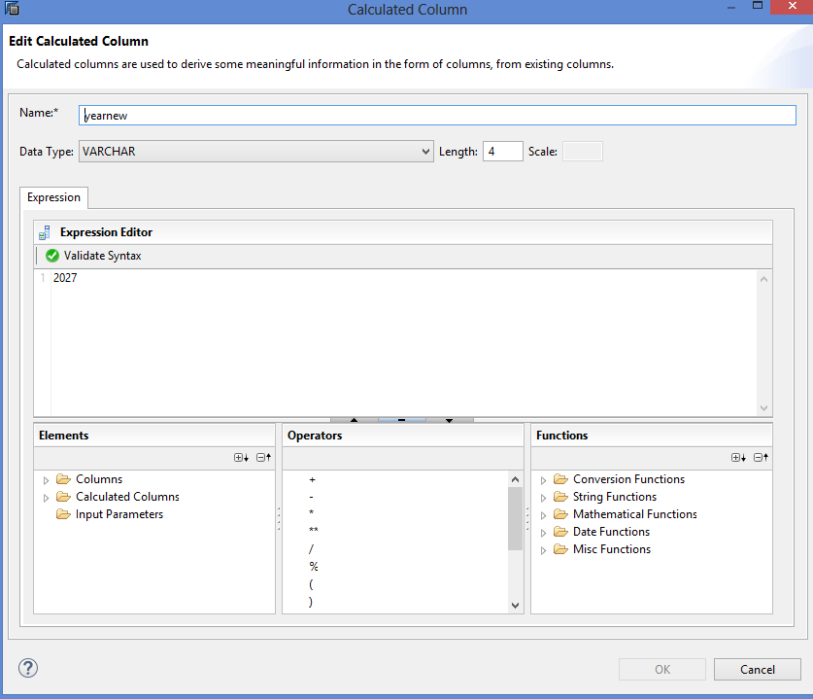

The output structure of **projection_4** node should be similar to screen shot

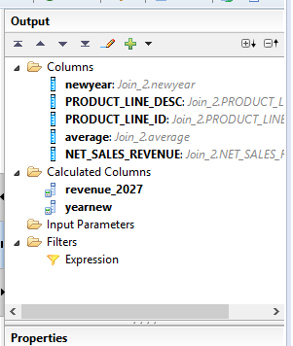

5.24) Drag a **union** node and connect **join_1** node and **projection_4** node to it

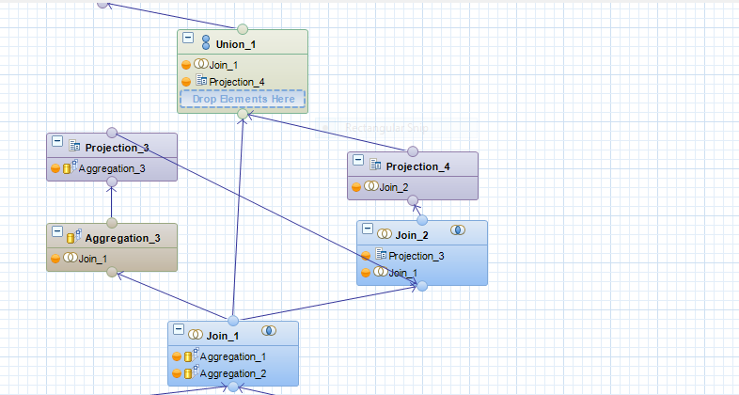

5.25) Drag and drop fields from the source field to the target field as per the screen shot below:

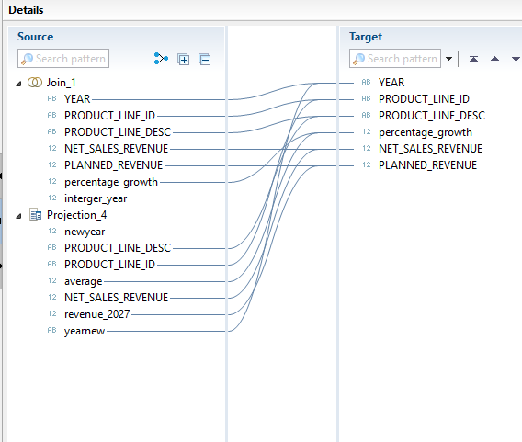

5.26) Connect **union_1** node to the projection node connected to the semantics

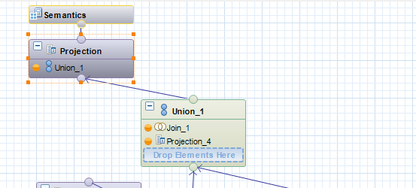

**Note:** If an aggregation node is connected to semantics, change it to projection node. Right click on the aggregation node and select switch to projection node.

The output structure of the final projection node should be similar to the screen shot below:

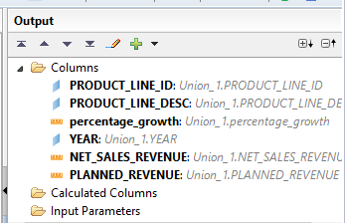

**Note: Finally, your model should look similar to the below screen shot:**

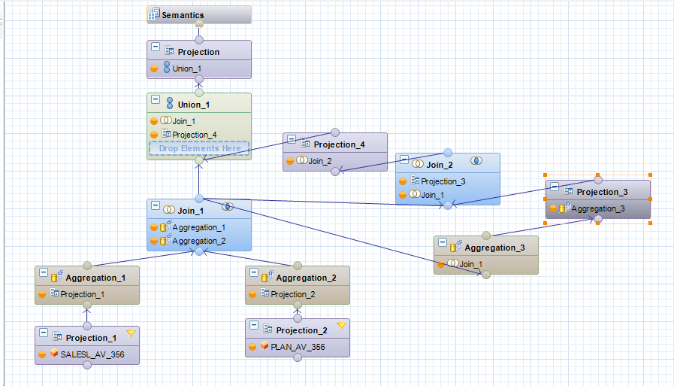

5.27) Click on the semantics tab and change the type of the variables and the aggregation level as shown in the screenshot:

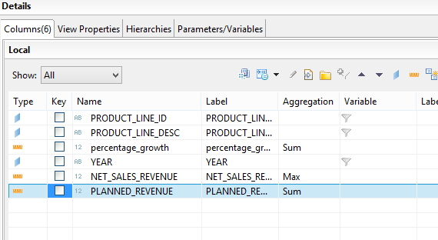

**f.) Question: Paste the screen shot of the semantics tab of the calculation view**

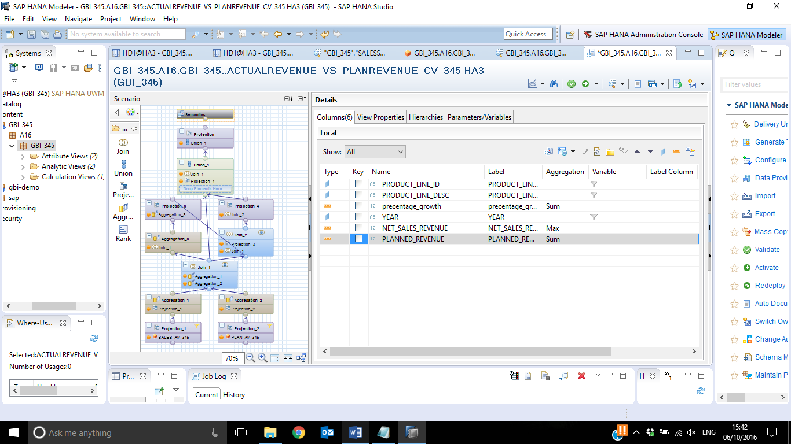

5.28) Click on save and validate objects and then activate the view.

**g.) Question: Paste the Screen shot of the status message after activation**

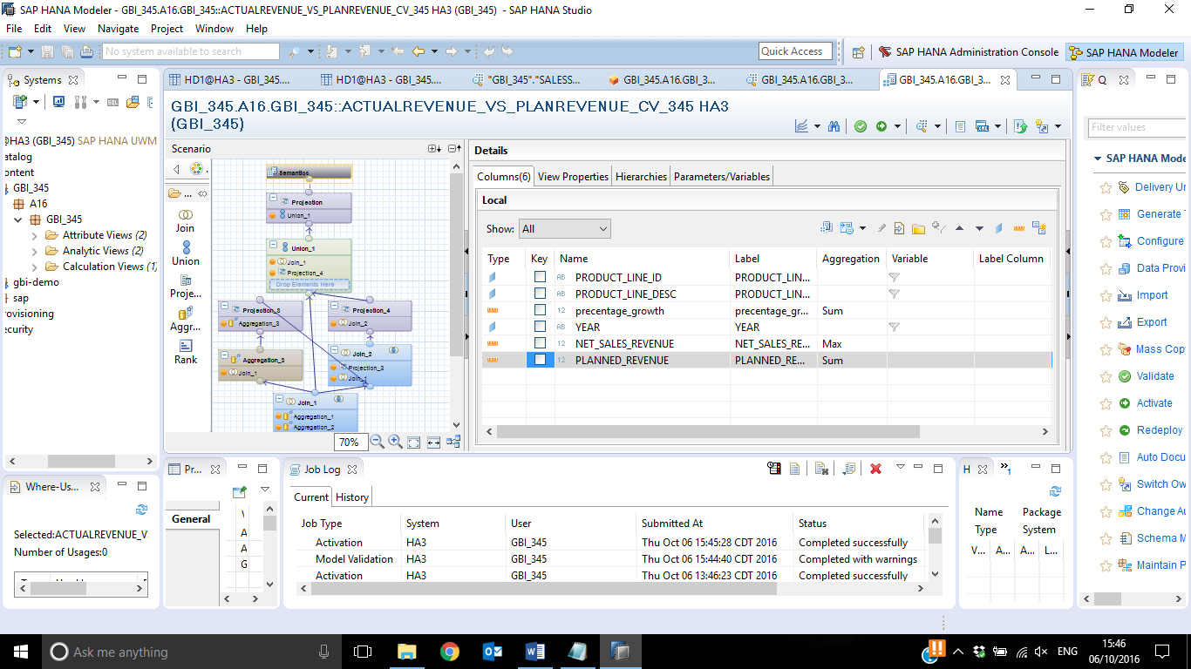 **_____________________________________________________________________**

**h.) Click on the data preview button present on the right hand corner and paste the screen shot of your raw data of your view**

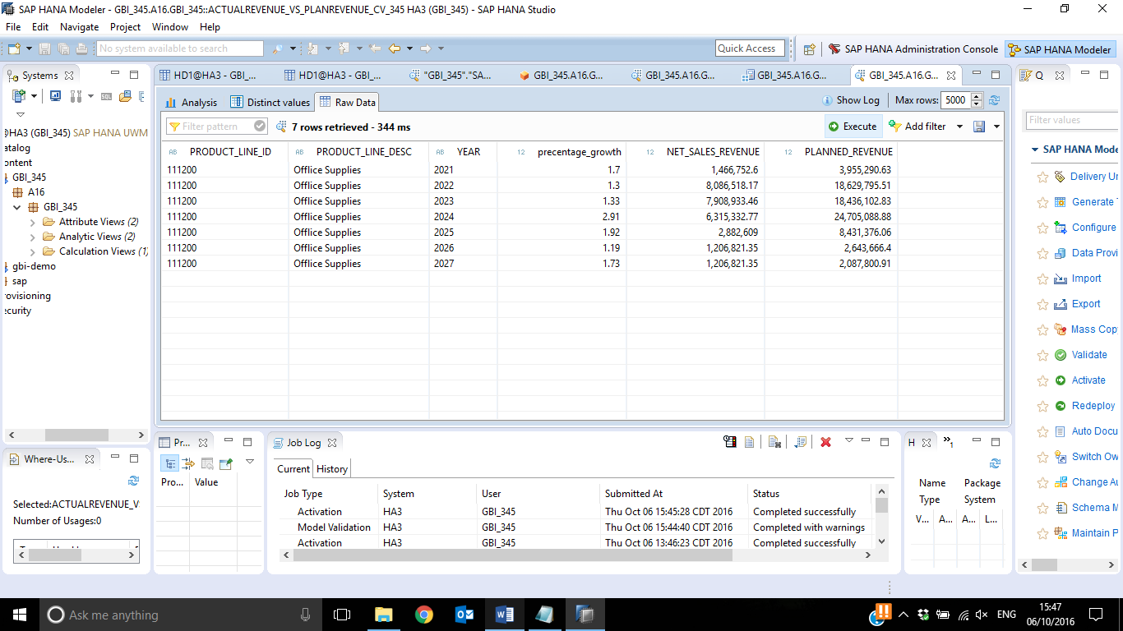 **____________________________________________________________________**

**6.) Analysis**

In this section we are going to compare the planned revenue and the actual revenue over the years 2021 to 2026 using the line chart and also analyze the trend of the planned revenue.

6.1.) Go to the **analysis tab**, place **year** under the **label axis** tab and place **planned_revenue** under the **value axis** tab.

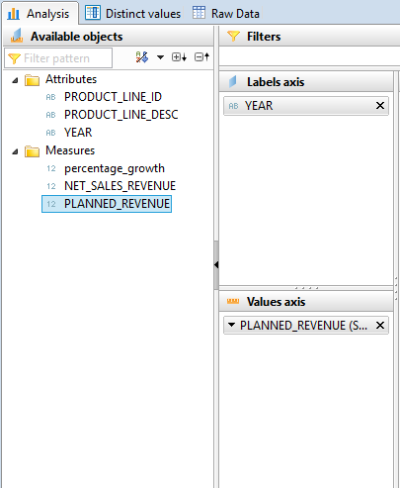

6.2) Under the type of charts, select the **line chart** and select the option **line**

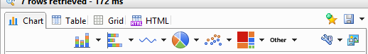

1. **Question: Paste the screen shot of the line chart**

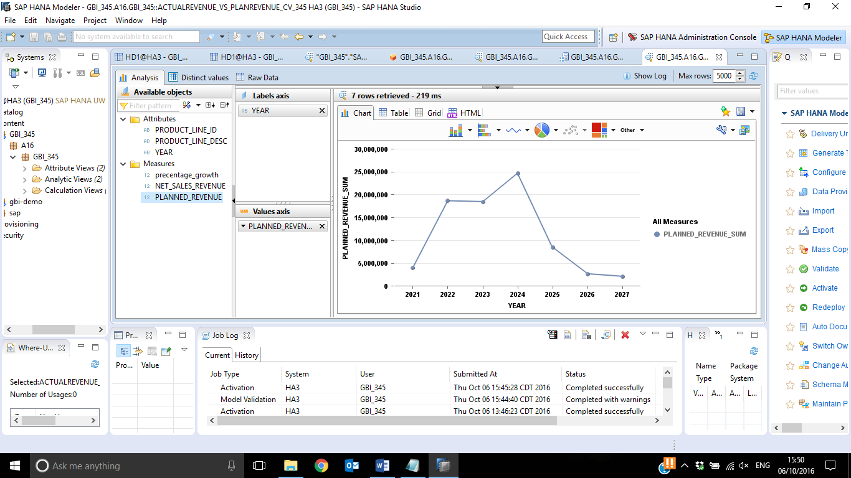

6.3.) Under the available objects section, under the attributes, right click on the year and select add to filters option

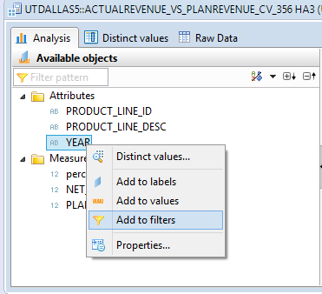

Select years 2021 to 2026 as shown in the screen shot

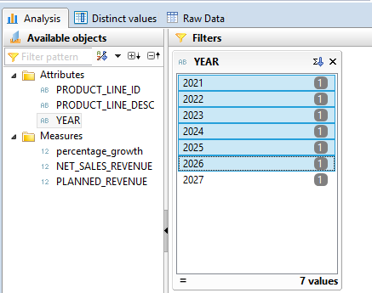

6.4) Add the net_sales_revenue to the values axis section as per the screenshot:

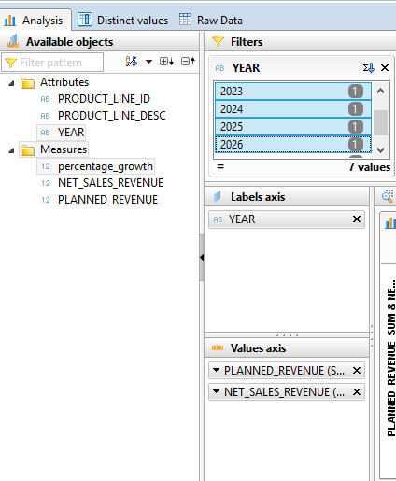

**j.) Question: Paste the screen shot of your chart**



